

**TEST 2 HOMEOSTASIS**

**Section One: Multiple-choice /10 marks**

**Section Two: Short Answer /33 marks**

**Section Three: Extended Answer /12 marks**

**Total: /55 marks**

Name: ________________________________________

**Section One: Multiple-choice 10 marks**

Suggested working time: 10 minutes

Select the best alternative from the answers given and mark your choice like this:

(a) (b) (c) (d)

|  |  |
| --- | --- |
| 1. (a) (b) **(c)** (d)  2. (a) (b) **(c)** (d)  3. (a) **(b)** (c) (d)  4. (a) (b) (c) **(d)**  5. (a) (b) (c) **(d)** | 6. (a) (b) **(c)** (d)  7. (a) **(b)** (c) (d)  8. **(a)** (b) (c) (d)  9. (a) (b) **(c)** (d)  10. (a) **(b)** (c) (d) |

**Section Two: Short Answer** Suggested working time: 25 minutes

**Question 1**  **(2 marks)**

Explain the difference between negative feedback and positive feedback, using examples.

* Negative feedback opposes the original stimulus, e.g. an increase blood glucose levels will triggers a series of responses that cause a decrease in blood glucose levels.(1)
* Positive feedback reinforces/enhances the original stimulus, e.g. oxytocin intensifies unterine contractions during labour. (1)

(2 marks)

**Question 2**  **(7 marks)**

To investigate the effects that air temperature has on body temperature, a naked subject stood in a room especially designed for controlling air temperature. The subject was exposed to 48oC to monitor the body’s response to dry heat. After a rest period, the same subject was exposed to 5oC to monitor the body’s response to dry cold. The data recorded are shown in the graphs below.

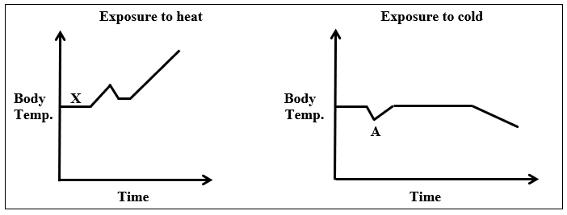

1. What would the body temperature be at X (in degrees Celsius)?_

**370C (Normal range is 35.6-37.80C (1)**

(1 mark)

1. List two physiological adjustments the body is making to cope with the situation at point A in the graph and explain how these may be of benefit.

|  |  |
| --- | --- |
| **ADJUSTMENT (1ea)** | **BENEFIT (1ea)** |
| **Increasing metabolism**  **Shivering**  **Increased production of adrenaline, thyroxine**  **Vasoconstriction of blood vessels** | **Creating metabolic heat**  **Creating heat by muscle contraction**  **Increased metabolism [increased production of heat]**  **Reducing heat loss through skin** |

(2 marks)

1. Using the information in the graphs alone, did the most **efficient** temperature regulation occur when the subject was exposed to heat or to cold? Give **one reason** for your answer.

**More efficient when exposed to cold (1), because they maintained normal body temperature for a longer period (1) OR showed slower rate of change in body temperature OR less absolute change in body temperature (1)**

(2 marks)

1. After an extended period of time the person exposed to heat would also start to feel incredibly thirsty. Explain how this sensation is instigated by the body.

Osmoreceptor in the hypothalamus (1) detect an increase in osmotic pressure (1) due to water loss (sweating)

(2 mark)

**Question 3**   **(12 marks)**

The nephron of the kidney plays a key role in maintaining homeostasis of body fluid composition by removing the appropriate levels of water from the body.

1. In the following space complete the feedback loop that shows your body’s response after running 10km and sweating profusely.

(6 marks)

**Stimulus****Increase osmotic pressure (1)**

Receptor **Osmoreceptors (1)**

Modulator **Hypothalamus (1) Stimulates posterior pituitary to release ADH (1)**

Effector **DCT and Collecting duct of the nephron (Kidney) (1)**

Response **Increase permeability to water which results in increase reabsorption of water into blood (1)**

1. After a night of drinking alcohol, a person may wake in the morning to find they are very dehydrated as alcohol inhibits the production of ADH.

Explain why the individual would feel dehydrated in the morning after drinking alcohol.

**ADH production limited so DCT and collecting duct walls less permeable to water**

**Little water reabsorbed even though may be dehydrated/Osmoreceptors stimulated**

**Fluid continually lost as urine, so become dehydrated**

(3 marks)

1. Explain the roles the skin and the digestive system play in balancing the water and salt balance in the human body.

**Must: Water and salt lost by evaporation from the skin/sweating (1)**

**Water is absorbed from the food in the colon (1)**

**Salt is absorbed from food in the small intestine (1)**

**or**

**water enters body by drinking, salt is eaten (1)**

**and then nutrients are absorbed into the blood (1)**

(3 marks)

**Question 4 (12 marks)**

An athlete had pH levels in his blood measured immediately before and after a 100 metre sprint. The results showed a decrease in pH from 7.45 to 7.35.

1. Why did the blood pH levels change?

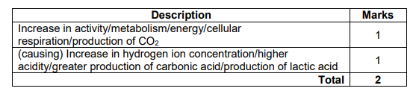 (2 marks)

1. The decrease in pH was detected by receptors that initiated a response to a change in the rate of breathing. Describe the events that enabled this change in the breathing rate to occur.

Drop in pH detected by chemoreceptors (1)

In the carotid and aortic bodies (1)

Nerve impulse sent to the respiratory centre/ medulla oblongata (1)

Nerve impulse sent to diaphragm via phrenic nerve (1)

Nerve impulse sent to intercoastal muscles via intercoastal nerve (1)

Increased contraction of respiratory muscles (1)

(5 marks)

1. Under normal circumstances, the level of oxygen in the blood does not influence breathing rate. Under what circumstance will oxygen have an effect and what effect will it be?

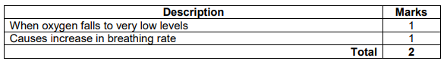

(2 marks)

Free divers are athletes who descend underwater as far as possible without breathing apparatus. Before diving into the water, the free diver deliberately hyperventilates.

1. State what hyperventilation is and why a person who hyperventilates before free diving is

at an increased risk of drowning

**Hyperventilation is rapid deep breathing causing a drop in CO2 levels (1)**

**The diver could deplete their oxygen levels to a point they lose consciousness (1)**

**before the chemoreceptors detect high enough Co2 levels stimulate the diver to take a breath (1)**

(3 marks)

**Section Three: Extended Answer**

Suggested working time: 20 minutes

**Question 5 (12 marks)**

There are several hormones involved in the maintenance of optimal glucose levels in the blood.

1. Identify **three** of these hormones, state the specific location where they are produced and explain how they assist in the maintenance of optimal blood glucose levels.

(12 marks)

|  |  |
| --- | --- |
| **Description** | **Marks** |
| Four marks each: one for hormone, one for source, two for regulation.  Any three of the following hormones. | |
| Glucagon | 1 |
| Produced by the alpha cells/Islets of Langerhans/pancreatic islets | 1 |
| Any two of:  • glycogenolysis of glycogen/breakdown of glycogen into glucose in the liver  • gluconeogenesis of lipids/breakdown of lipids into glucose/lipolysis in the liver/in adipose tissue  • gluconeogenesis of amino acids/breakdown of amino acids into glucose | 1-2 |
| **OR** | |
| Cortisol | 1 |
| Produced by the adrenal cortex | 1 |
| Any two of:  • glycogenolysis of glycogen/breakdown of glycogen to glucose  • removal of amino acids from muscle cells  • amino acids transported to liver for gluconeogenesis/amino acid to glucose | 1-2 |
| **OR** | |
| Adrenaline/noradrenaline | 1 |
| Produced in the adrenal medulla | 1` |
| Any two of:  • glycogenolysis of glycogen/breakdown of glycogen to glucose  • glycogen in muscles is acted on to produce lactic acid/lactic acid is converted to glucose in the liver  • increased numbers of insulin receptors on cell surface/Increased sensitivity of insulin receptors | 1-2 |
| **OR** | |
| Insulin | 1 |
| Produced by the beta cells/Islets of Langerhans/pancreatic islets | 1 |
| Any two of:  • glycogenesis of glucose/conversion of glucose to glycogen in liver/muscles  • conversion of glucose into lipids in adipose tissue  • transport of glucose into cells/acts as a receptor for glucose on cell membranes (for respiration) | 1-2 |
| **OR** | |
| Thyroxine | 1 |
| Produced by the thyroid gland | 1 |
| Enhances absorption of glucose from the small intestine (into the blood  stream) | 1 |
| Increases glucose metabolism in cells/reduced blood glucose due to increased respiration | 1 |
| **Total** | **12** |